

|  |
| --- |
|  |
| |  | | --- | | **USER MANUAL** |  |  |  | | --- | --- | | **Document information** | | | Project Name | Material Master Data Management | | Module | MM | | Created by | Nguyễn Thị Ý Nhi - SS160124  Vương Thanh Hà - SS160126  Tạ Thị Bích Diễm - SS171321 | | Version | 1.0 | | Date | 4/12/2024 | |
|  |
|  |

| **Change history** | | | | | |
| --- | --- | --- | --- | --- | --- |
| Changed date | Items have been changed | Changed content/Reason | Updated by | Type  (A/C/D) | Version |
| 4/12/2024 | All | First Release |  | A | 1.0 |
|  |  |  |  |  |  |
|  |  |  |  |  |  |
|  |  |  |  |  |  |
|  |  |  |  |  |  |
|  |  |  |  |  |  |
|  |  |  |  |  |  |
| ***A*** *– Create* ***C*** *– Change* ***D*** *– Delete* | | | | | |

|  |  |  |  |  |
| --- | --- | --- | --- | --- |
| **FPT Signature** | | | | |
|  | **Full name & Role** | **Signature** | **Date** | **Note** |
| **Created by** | Nguyễn Thị Ý Nhi - SS160124  Vương Thanh Hà - SS160126  Tạ Thị Bích Diễm - SS171321 |  | 4/12/2024 |  |
| **Reviewed by** | Bùi Thị Ny Ny |  | 6/12/2024 |  |
| **Approved by** |  |  |  |  |

|  |
| --- |
| **Table of Contents** |

**1 OVERVIEW 5**

1.1 Process used in guide document 5

**2 USER MANUAL 6**

2.1 Overview 6

2.2 Upload Flow 6

2.2.1 Transaction code 6

2.2.2 Detail implementation 6

2.2.2.1 Create New Material 6

2.2.2.2 Extend the Material (Tick “Extend) 10

2.2.2.3 Extend Material (Not Tick “Extend) 15

2.2.2.4 Create and Extend Material 20

2.2.2.5 Create Material Description for Multi-language 25

2.3 Display Flow 28

2.3.1 Transaction code 28

2.3.2 Detail implementation 28

2.3.2.1 Display ALV 28

2.3.2.2 Delete line Material data 30

2.3.2.3 Undelete line Material data 35

2.3.2.4 No edit data 39

2.3.2.5 Edit 1 line Material with 1 field 41

2.3.2.6 Edit 1 line Material with multiple fields 44

2.3.2.7 Edit multiple lines Material with multiple fields 47

# OVERVIEW

## Process used in guide document

| **BBP No** | **Definition** | **Note** |
| --- | --- | --- |
| ZPG_MM_GR03 | Material Master Data Management |  |

# USER MANUAL

## Overview

The purpose of the upload flow is to provide a function for users to create and extend materials by downloading an Excel template containing the required data and uploading material data via Excel files simply and effectively. Besides, the function allows users to switch between installed languages ​​by downloading a template file to fill in information and material usage language.

With the display flow, it can be used to display information material and allow users editing of material data which can include multiple materials in an intuitive way while ensuring that the data entry process is carried out accurately and without errors.

## Upload Flow

### Transaction code

|  |  |
| --- | --- |
| **T-code** | **Description** |
| ZMM01 | Material Master Data Management |

### Detail implementation

#### 2.2.2.1 Create New Material

**“*ZMM01*”** is now entered in the Transaction box

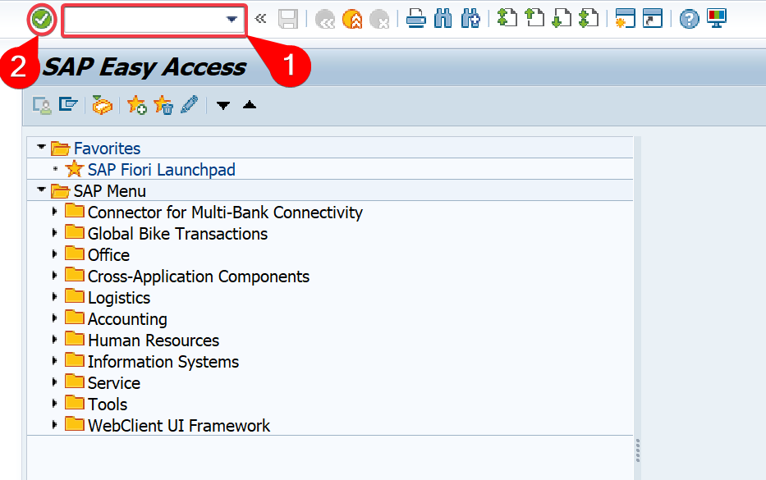

Click ***Enter*** 

In the *Material Master Data Management* screen, select **“*Upload*”**

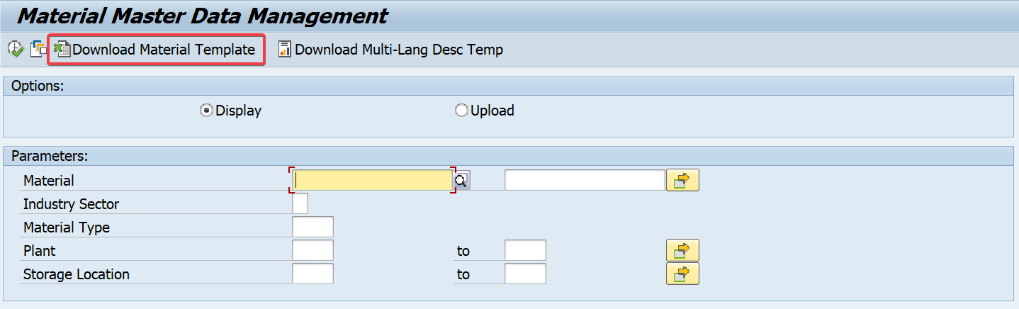

Click on “***Download Excel Template*”**

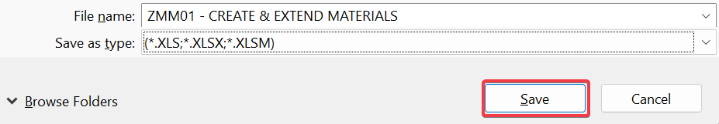

Click on “***Save”***

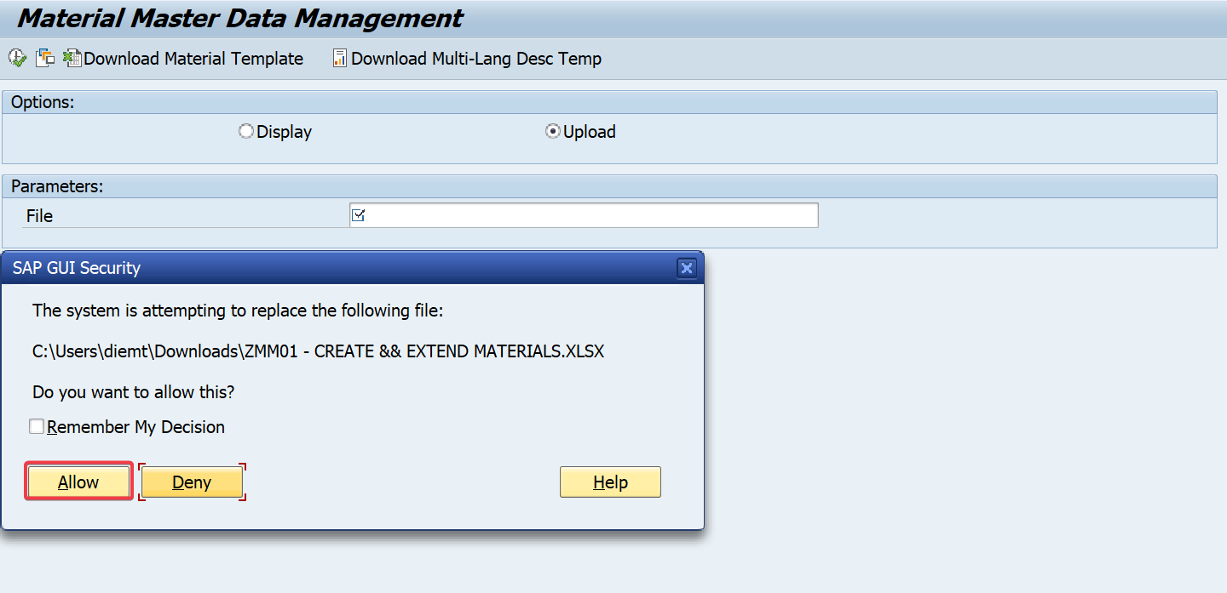

Click on “***Allow”***

You will receive a message that says: 

Based on the *Excel Template* from downloaded file locally, enter the following information:

|  |  |  |  |
| --- | --- | --- | --- |
| **No.** | **Field name** | **M/O** | **Description** |
| 1. | Material Number | M | Default: ######## (Alphanumeric) |
| 2. | Industry Sector | M | Default: E |
| 3. | Material Type | M | Default: HAWA, ZDIE |
| 4. | Plant | O | Default: CT00, FU24, DN00 |
| 5. | Storage Location | O | Default: CT01, DN01, TG01 |
| 6. | Material Description | M | Describe material information |
| 7. | Base unit of measure | M | The smallest basic unit to calculate |
| 8. | Material Group | M | Default: PHONE, TABLET, LAPTOP, ZREPAIR |
| 9. | General item category group | O | Default: NORM, LEIS |
| 10. | Unit weight | M | Unit of measurement for weight (Trading Goods) |
| 11. | Language Key | M | Default: EN |
| 12. | Purchasing Group | O | Default: F00 |
| 13. | Batch Management | O | Default: X |
| 14. | Planned Delivery Time | O | Default: Number |
| 15. | GR Processing Time | O | Default: Number |
| 16. | Price Determination | O | Default: 2 |
| 17. | Valuation Area | O | Default: CT00, FU24, DN00 |
| 18. | Valuation Class | O | Default: 3100 |
| 19. | Price Control | O | Default: V |
| 20. | Price Unit | O | Default: 1 |
| 21. | Moving Price | O | Default: 000.000 |
| 22. | Attribute 1 | O | Default: Text (Maximum 255) |
| 23. | Attribute n | O | Default: Text (Maximum 255) |

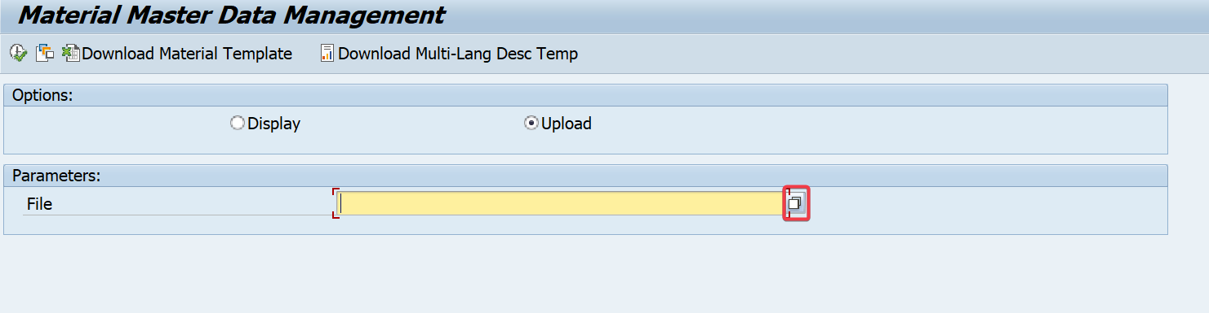

In the “***File*”**, click on ****icon to choose file from local file

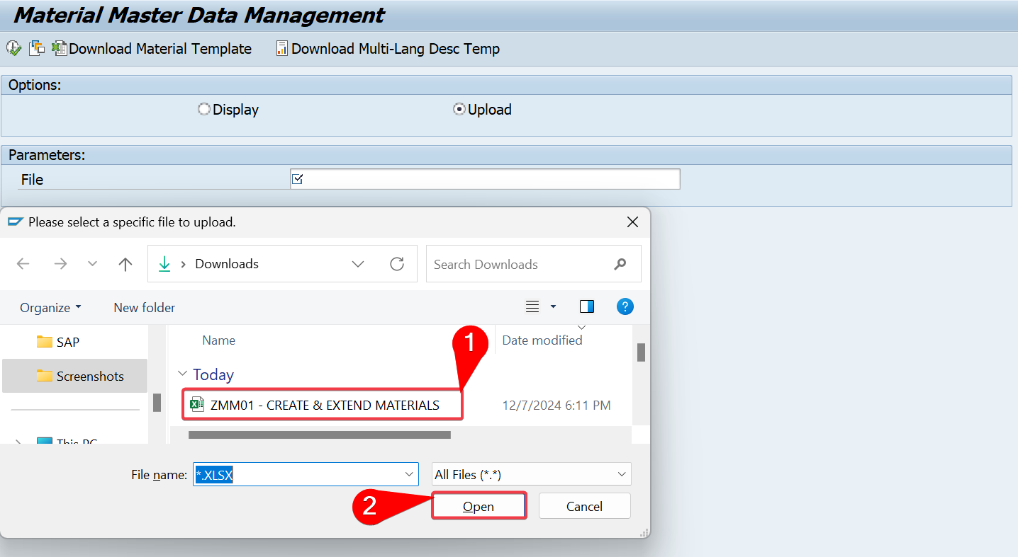

Choose “***ZMM01_CREATE AND EXTEND MATERIAL*”** file

Click on “***Open*”**

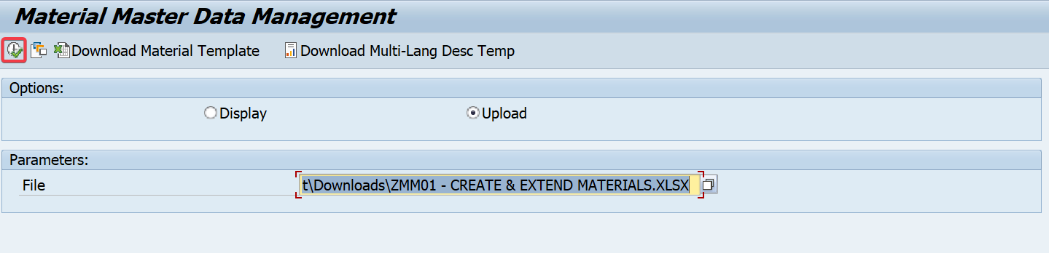

Click on ***Execute***  icon

You will receive the message that says:  and display status: 

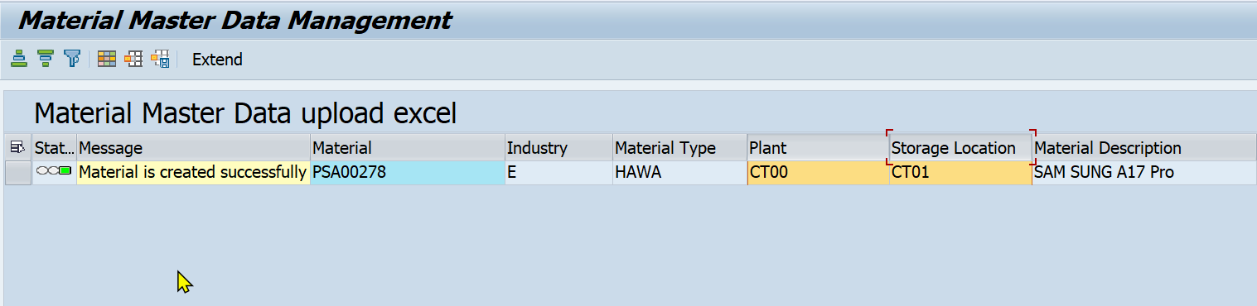

Click on to return

#### 2.2.2.2 Extend the Material (Tick “Extend)

In the SAP Easy Access screen,enter the transaction code ***ZMM01***

Press ***“Execute/Enter”* **



In the *Material Master Data Management* screen, select **“*Upload*”**



Click on the “***Download Excel Template”*** button. 



Click on “***Save”***



Click on “***Allow”***

You will receive a message that says: 

In the *Excel file,* fill in the Material number information that you want to *Extend*. Ensure the ***Material Number*** exists in the system.

|  |  |  |  |
| --- | --- | --- | --- |
| **No.** | **Field name** | **M/O** | **Description and Example** |
| 1. | Material Number | M | Already exists in the system. Default: ######## |
| 2. | Industry sector | M | Default: E |
| 3. | Material type | M | Default: HAWA, ZDIE |
| 4. | Plant | O | Default: CT00, FU24, DN00. |
| 5. | Storage location | O | Default: CT01, DN01, TG01. |
| 6. | Material Description | M | Describe material information |
| 7. | Base unit of measure | M | The smallest basic unit to calculate |
| 8. | Material Group | M | Default: PHONE, TABLET, LAPTOP, ZREPAIR |
| 9. | Unit Weight | M | Unit of measurement for weight (Trading Goods) |
| 10. | Language Key | M | Default: EN |
| 11. | Class Type | O | Default: 023 |
| 12. | Class | O | Default: Z_TECH_BATCH |
| 13. | Purchasing Group | O | Default: F00 |
| 14. | Batch Management | O | Default:X |
| 15. | Price determine | O | Default: 2 |
| 16. | Valuation Area | O | Default: CT00, FU24, DN00 |
| 17. | Valuation class | O | Default: 3100 |
| 18. | Price control | O | Default: V |
| 19. | Price unit | O | Default: 1 |
| 20. | Moving Price/Per.Unit Price | O | Default: 000.000 |
| 21. | Attribute 1 | O | Default: Text (Maximum 255) |
| 22. | Attribute 2 | O | Default: Text (Maximum 255) |
| 23. | Attribute 3 | O | Default: CT00, FU24, DN00 |
| 24. | Extend | O | Tick/TRUE |

Provide new **Plant**, **Storage Location**, and other relevant details to extend the material to a new organizational level.

The Extend checkbox should be “***Tick***” or enter “***TRUE***” in the Excel file.

After checking and making sure that all data fields in the Excel file are valid.

Return to the*Material Master Data Management*screen, select **“*Upload*”**

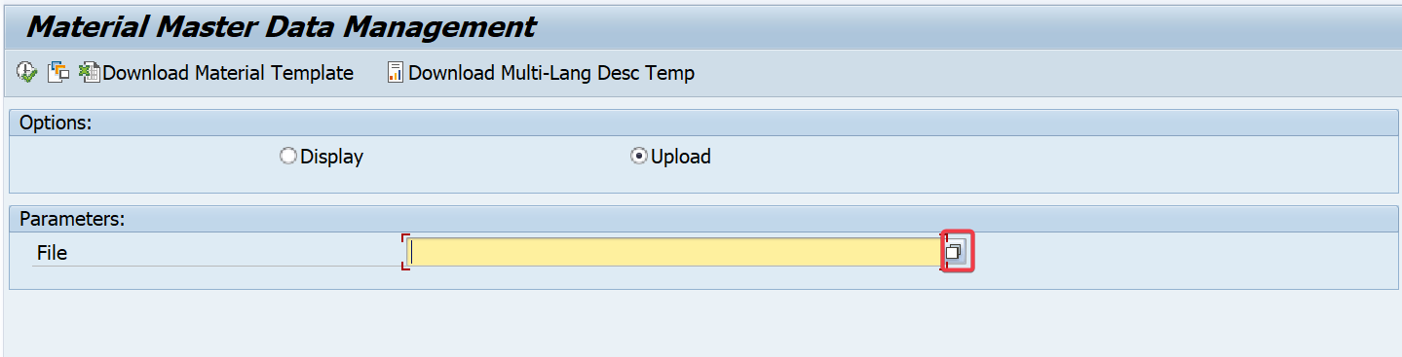

In the “*File”*, click on ****icon to choose file from local file.



Choose “***ZMM01_CREATE AND EXTEND MATERIAL*”** file

Click on “***Open*”**



Click “**Execute (F8)**”  to *extend* the material.

You will receive a message that says:  and the status column will turn green: 

Click on to return to the SAP Easy Access screen.

#### 2.2.2.3 Extend Material (Not Tick “Extend)

***“ZMM01”*** is now entered in the Transaction box



Click ***Enter*** 

In the *Material Master Data Management* screen, select **“*Upload*”**



Click on the “***Download Excel Template”*** button. 



Click on “***Save*”**



Click on “***Allow*”**

You will receive a message that says: 

Based on the *Excel Template* from downloaded file locally, enter the following information:

|  |  |  |  |
| --- | --- | --- | --- |
| **No.** | **Field name** | **M/O** | **Description and Example** |
| 1. | Material Number | M | Default: ######## (Alphanumeric) and already exists in the system |
| 2. | Industry Sector | M | Default: E |
| 3. | Material Type | M | Default: HAWA, ZDIE |
| 4. | Plant | O | Default: CT00, FU24, DN00 |
| 5. | Storage Location | O | Default: CT01, DN01, TG01 |
| 6. | Material Description | M | Describe material information |
| 7. | Base unit of measure | M | The smallest basic unit to calculate |
| 8. | Material Group | M | Default: PHONE, TABLET, LAPTOP, ZREPAIR |
| 9. | General item category group | O | Default: NORM, LEIS |
| 10. | Unit weight | M | Unit of measurement for weight (Trading Goods) |
| 11. | Language Key | M | Default: EN |
| 12. | Purchasing Group | O | Default: F00 |
| 13. | Batch Management | O | Default: X |
| 14. | Planned Delivery Time | O | Default: Number |
| 15. | GR Processing Time | O | Default: Number |
| 16. | Price Determination | O | Default: 2 |
| 17. | Valuation Area | O | Default: CT00, FU24, DN00 |
| 18. | Valuation Class | O | Default: 3100 |
| 19. | Price Control | O | Default: V |
| 20. | Price Unit | O | Default: 1 |
| 21. | Moving Price | O | Default: 000.000 |
| 22. | Attribute 1 | O | Default: Text (Maximum 255) |
| 23. | Attribute n | O | Default: Text (Maximum 255) |

Return to the*Material Master Data Management*screen, select **“*Upload*”**



In the “*File”*, click on ****icon to choose file from local file.



Choose “***ZMM01_CREATE AND EXTEND MATERIAL*”** file

Click on “***Open*”**



Click “**Execute (F8)**” 

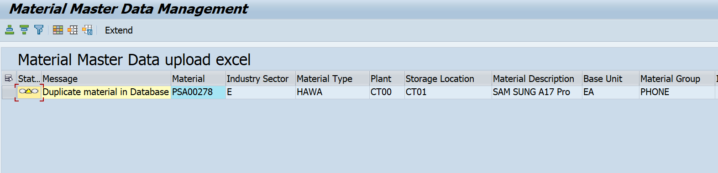

In the *Material Master Data Management Screen,* you will receive the message that says:

 and 

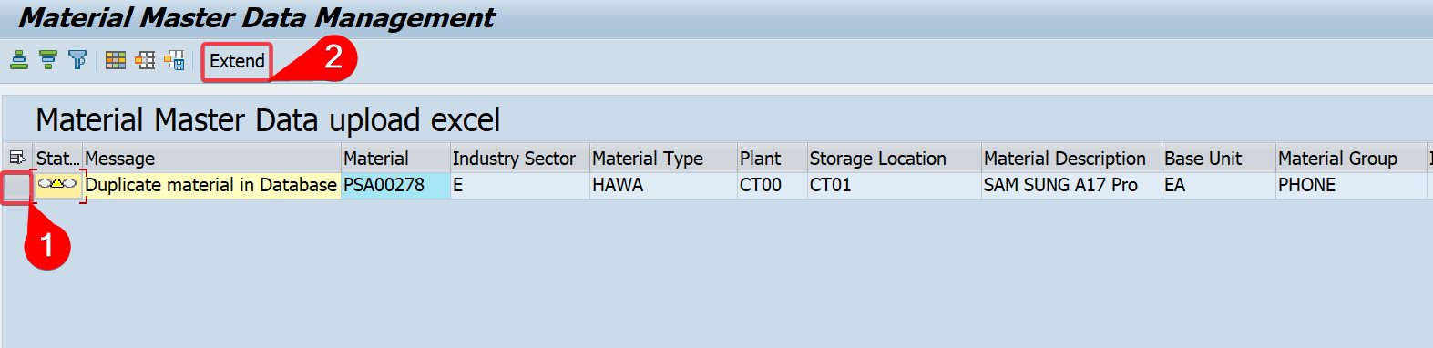

Choose ***Line*** that message says: “***Duplicate material in Database***”

Click on “***Extend***”

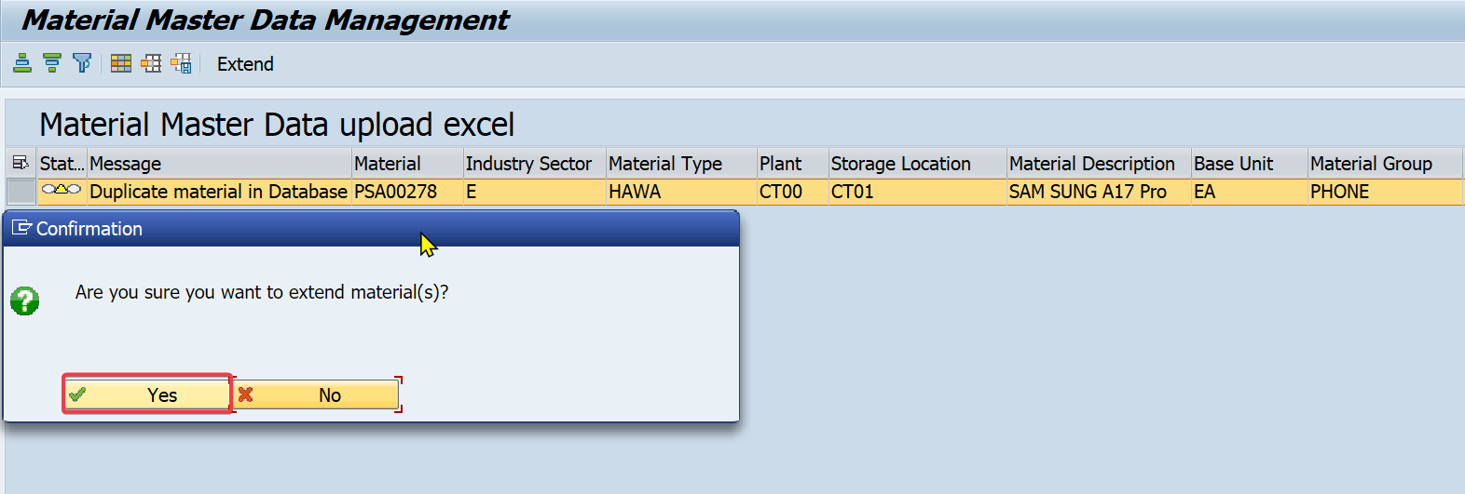

Press ***“Yes”***

In the *Extend Material* screen, enter the following information:

|  |  |
| --- | --- |
| **Plant** | **Storage Location** |
| CT00 (Can Tho) | CT01 (Trading Goods) |
| FU24 (FPT University) | TG01 (Trading Goods) |
| DN00 (Da Nang) | DN01 (Trading Goods) |

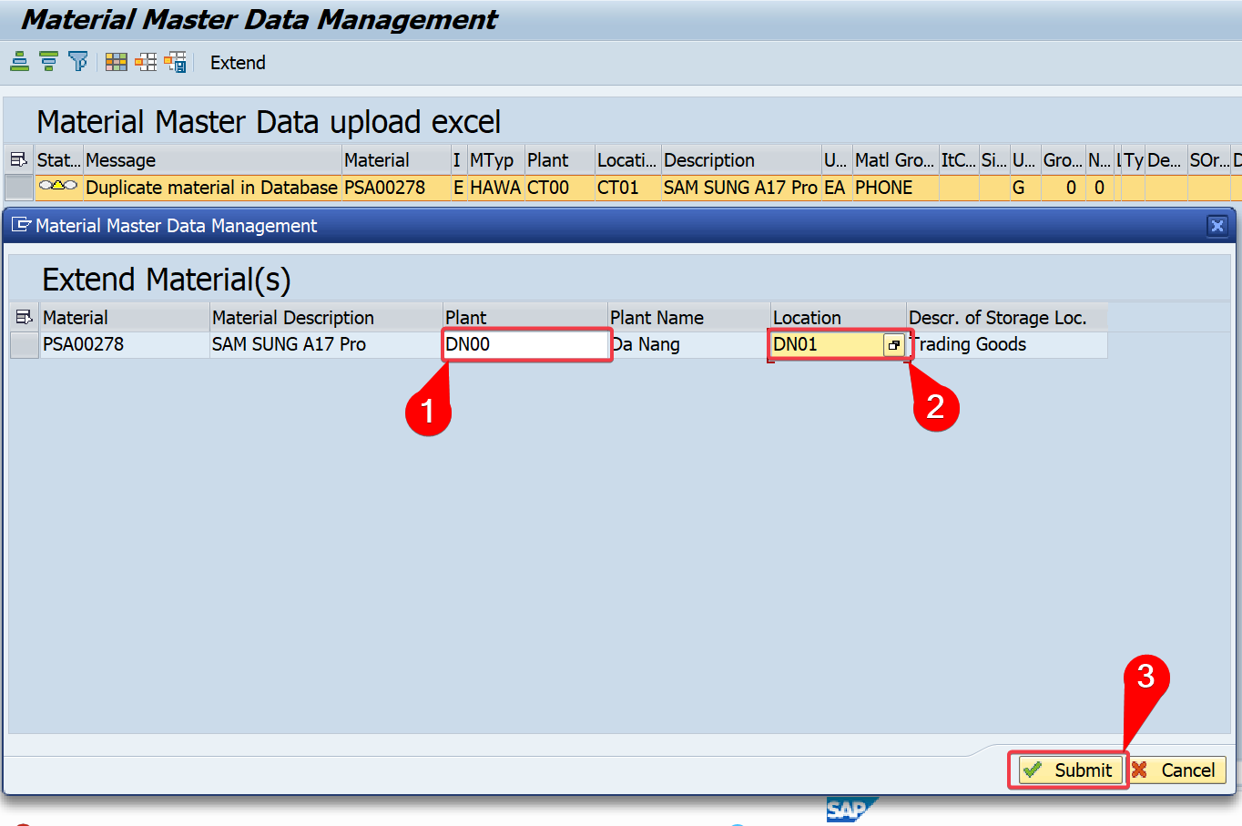

Click on . You will receive a message that says:

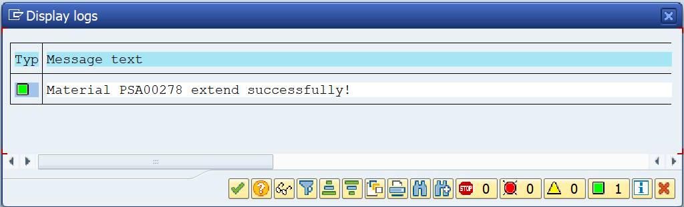

Click on 

Click on to return

#### 2.2.2.4 Create and Extend Material

In the SAP Easy Access screen,enter the transaction code ***ZMM01*** and press ***Enter* **



In the *Material Master Data Management* screen, select **“*Upload”***



Click on the “***Download Excel Template"*** button. 



Click on “***Save***”



Click on “***Allow”***

You will receive a message that says: 

Fill in the required material data for Create and Extend in the Excel template**.**

* For **Create New Material:**

|  |  |  |  |
| --- | --- | --- | --- |
| **No.** | **Field name** | **M/O** | **Description** |
| 1. | Material Number | M | Default: ######## (Alphanumeric) |
| 2. | Industry Sector | M | Default: E |
| 3. | Material Type | M | Default: HAWA, ZDIE |
| 4. | Plant | O | Default: CT00, FU24, DN00 |
| 5. | Storage Location | O | Default: CT01, DN01, TG01 |
| 6. | Material Description | M | Describe material information |
| 7. | Base unit of measure | M | The smallest basic unit to calculate |
| 8. | Material Group | M | Default: PHONE, TABLET, LAPTOP, ZREPAIR |
| 9. | General item category group | O | Default: NORM, LEIS |
| 10. | Unit weight | M | Unit of measurement for weight (Trading Goods) |
| 11. | Language Key | M | Default: EN |
| 12. | Purchasing Group | O | Default: F00 |
| 13. | Batch Management | O | Default: X |
| 14. | Planned Delivery Time | O | Default: Number |
| 15. | GR Processing Time | O | Default: Number |
| 16. | Price Determination | O | Default: 2 |
| 17. | Valuation Area | O | Default: CT00, FU24, DN00 |
| 18. | Valuation Class | O | Default: 3100 |
| 19. | Price Control | O | Default: V |
| 20. | Price Unit | O | Default: 1 |
| 21. | Moving Price | O | Default: 000.000 |

* For **Extend Material**:

Enter the Material Number that already exists in the system.

***“Tick”*** or enter ***“TRUE”*** the Extend checkbox to indicate that you want to extend the material.

Provide new ***“Plant, Storage Location”***, and other relevant details to extend the material to a new organizational level.

After checking and making sure that all data fields in the Excel file are valid.

Return to the*Material Master Data Management*screen, select **“*Upload*”**



In the “***File*”**, click on ****icon to choose file from local file.



Choose “***ZMM01_CREATE AND EXTEND MATERIAL*”** file.

Click on “***Open*”**



Click “**Execute (F8)**”  to extend the material.

You will receive a message that says:

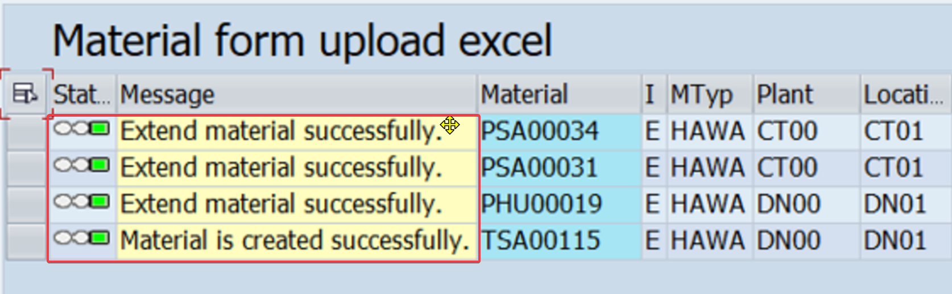

* For **Create New Material:**  and the status column will turn green: 
* For **Extend Material**:and the status column will turn green: 

Click on to return to the SAP Easy Access screen.

#### 2.2.2.5 Create Material Description for Multi-language

In the SAP Easy Access screen,enter the transaction code ***ZMM01*** and press ***Enter* **



In the *Material Master Data Management* screen, select **“*Upload”***

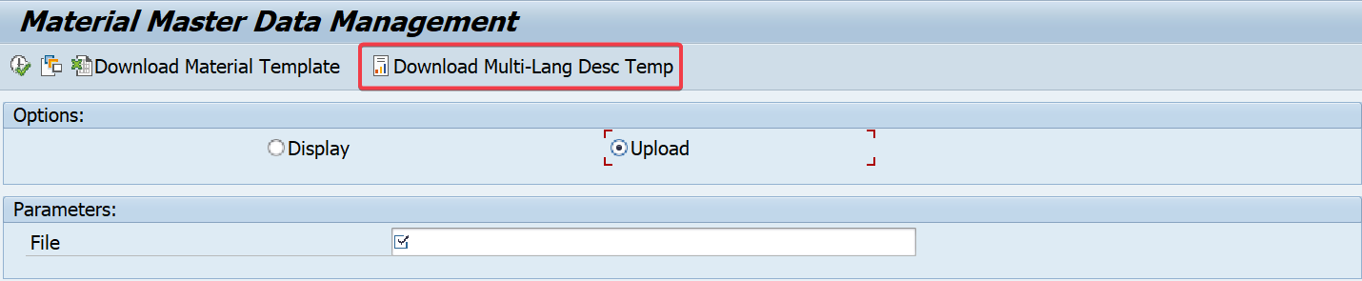

Click on the “***Download Multi-Lang Desc Temp "*** button 

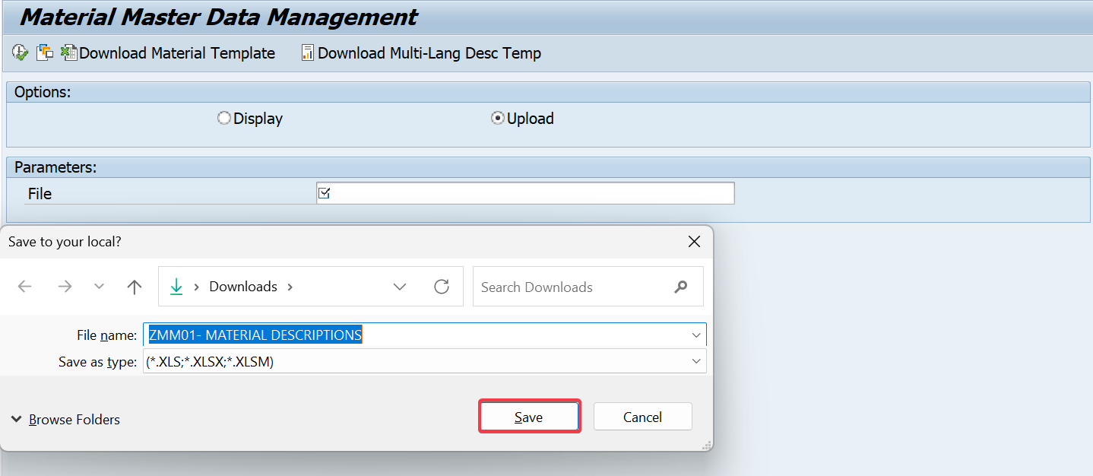

Click ***“ZMM01-MATERIAL DESCRIPTIONS”*** file

Click on “***Save***”

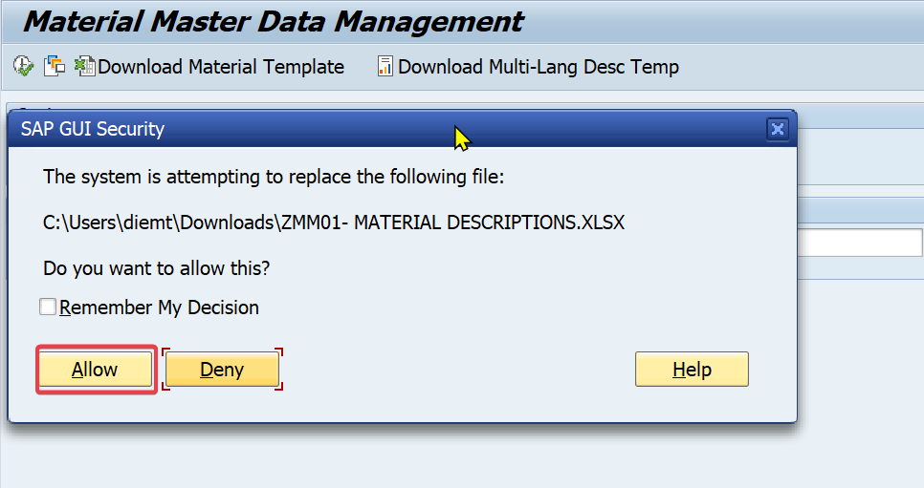

Click on “***Allow***”

You will receive a message that says: 



In *file* screen, click 

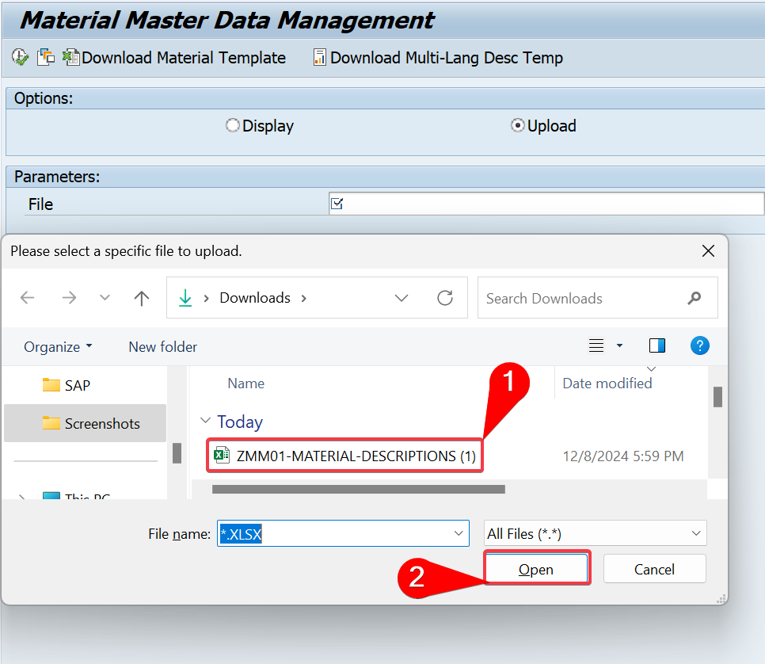

Choose “***ZMM01-MATERIAL-DESCRIPTION***” file

Click on “***Open***”

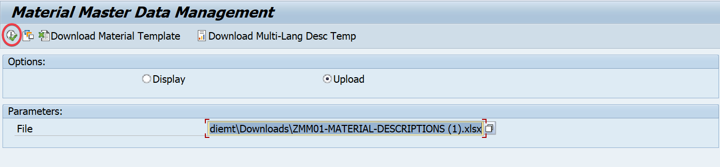

Click on “***Execute***”

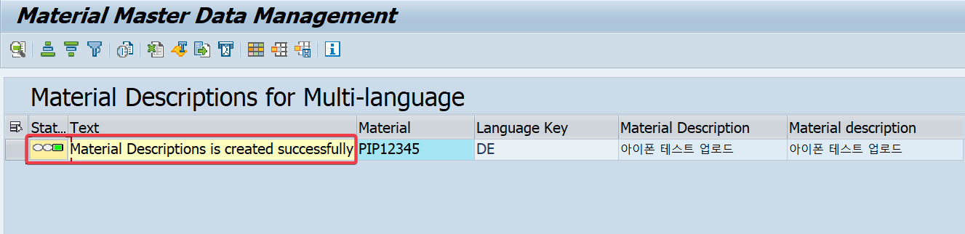

You will receive a message that says:  with status green 

Click on to return to the SAP Easy Access screen

## Display Flow

### Transaction code

|  |  |
| --- | --- |
| **T-code** | **Description** |
| ZMM01 | Material Master Data Management |

### Detail implementation

#### 2.3.2.1 Display ALV

Enter T-code "***ZMM01***" into the Transaction box.



Click on “***Execute”***  

Press **“*Enter”***

In the *Material Master Data Management* screen, select **“*Display”***

In the *Parameters* screen, if you want to be specific and limit the *Material and Plant*, you can enter the full information of the parameters

|  |  |  |  |  |
| --- | --- | --- | --- | --- |
| **Field** | **M/O** | **Data Value** |  | **Data Value** |
| Material | M | ######## (PSA00031) | to | ######## (PSA00034) |
| Industry Sector | O | Default: E |  |  |
| Material Type | O | Default:HAWA, ZDIE |  |  |
| Plant | O | Default: CT00, DN00, FU24 | to | Default: CT00, DN00, FU24 |
| Storage Location | O | Default: CT01, TG01, DN01 | to | Default: CT01, TG01, DN01 |

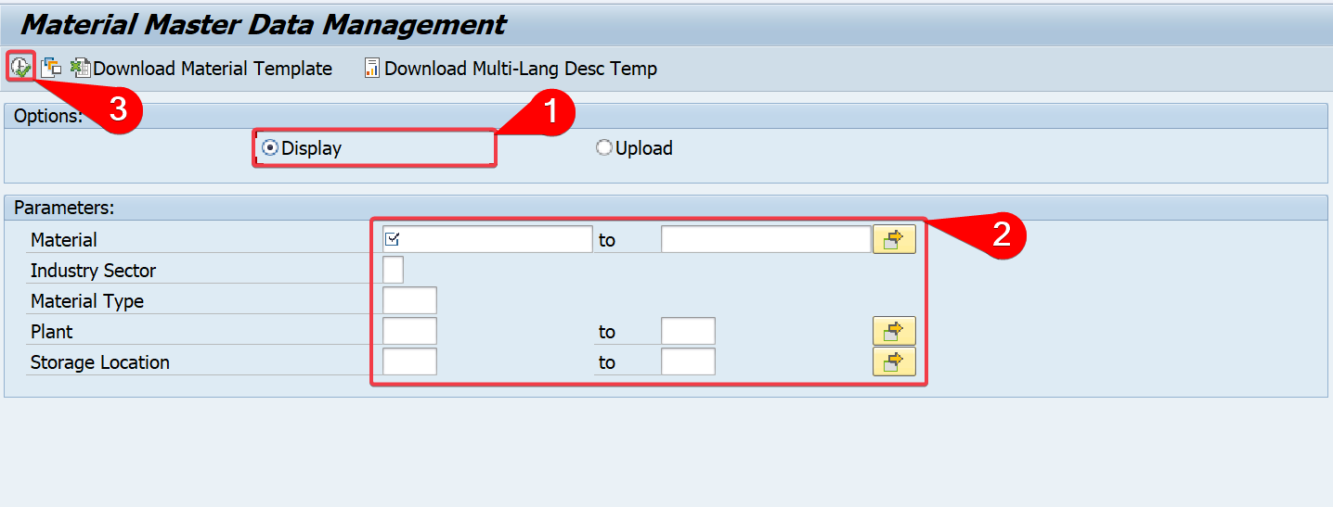

Click “***Execute”*** 

*In Display Materials screen,* the system displays material information

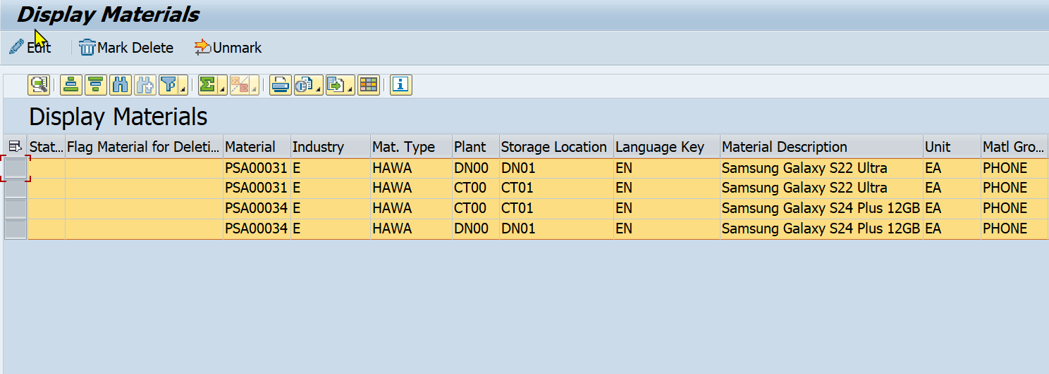

Click on to return to the *Display screen.*

#### 2.3.2.2 Delete line Material data

Enter T-code "***ZMM01***" into the Transaction box



Click ***Execute (Enter)*** 

In the *Material Master Data Management* screen, select **“*Display”***

In the ***Parameters****,* enter the following informations:

|  |  |  |  |  |
| --- | --- | --- | --- | --- |
| **Field** | **M/O** | **Data Value** |  | **Data Value** |
| Material (M) | M | ######## (PIP00256) | to | ######## (PSA00098) |
| Industry Sector | O | Default: E |  |  |
| Material Type | O | Default: HAWA, ZDIE |  |  |
| Plant | O | Default: CT00, DN00, FU24 | to | Default: CT00, DN00, FU24 |
| Storage Location | O | Default: CT01, DN01, TG01 | to | Default: CT01, DN01, TG01 |



Click ***Execute*** 

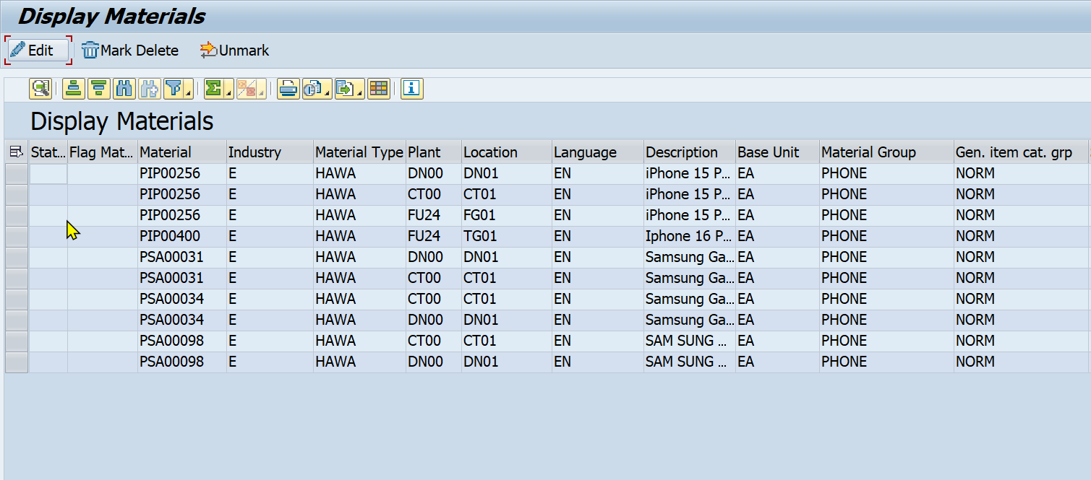

If delete one *Material*, select one line *Material data to Mark Delete.*

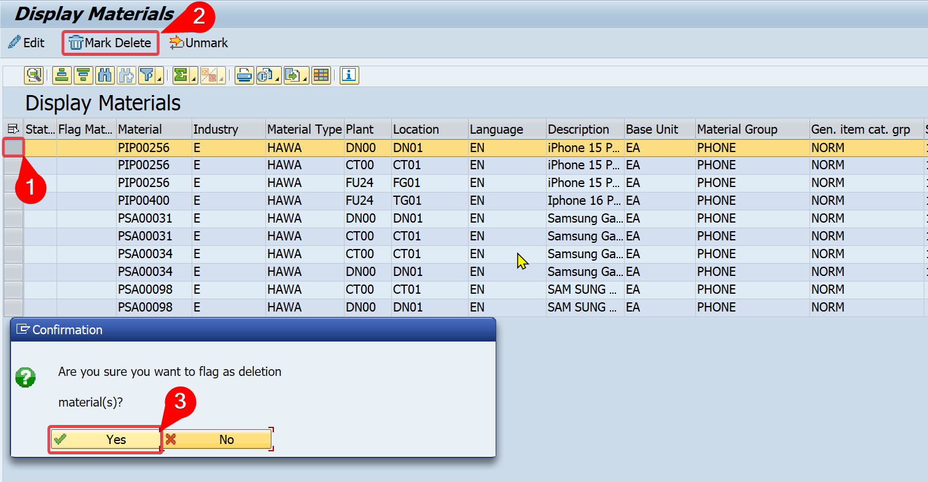

Select line *Material:* ***PIP00256*** *- Plant:* ***DN00****.*

Click 

Click 

You will receive message that says:



Click 

The result is status *displays green* square  and marked with  in the *Flag for Delete Material column.*

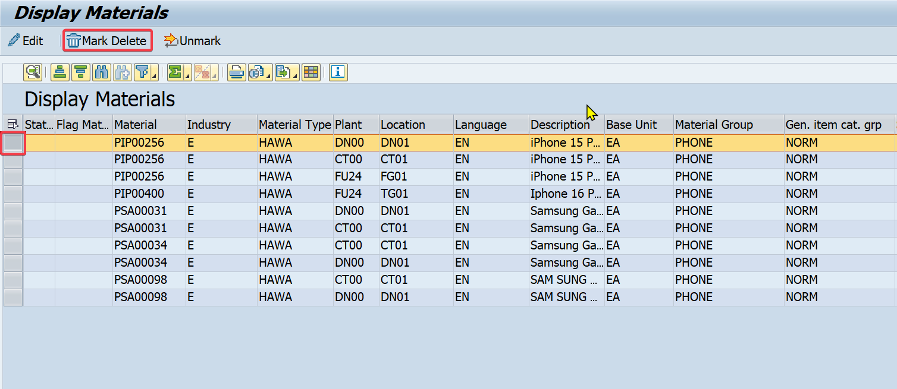

If you want to delete *multiple lines Material*, you need to select *multiple lines Material data to Mark Delete.*

Hold “***Ctrl”*** to select line *Material:* ***PIP00256*** *- Plant* ***FU24***and line *Material:* ***PSA0003****1 - Plant:* ***DN00***

Click 

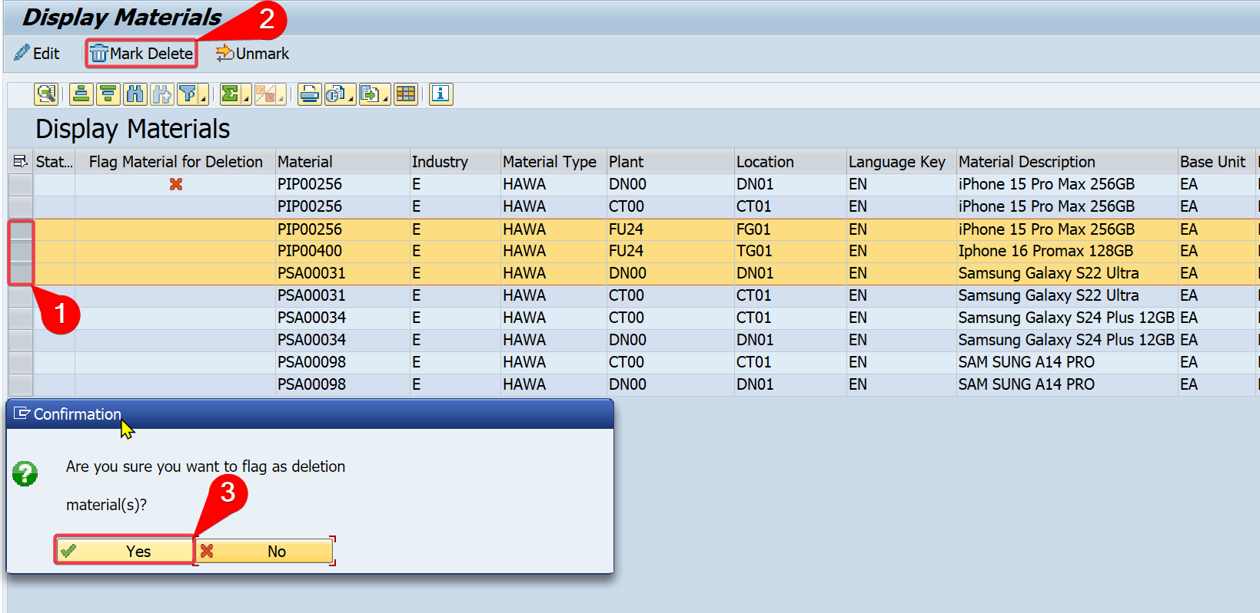

Click 

You receive the message that says:

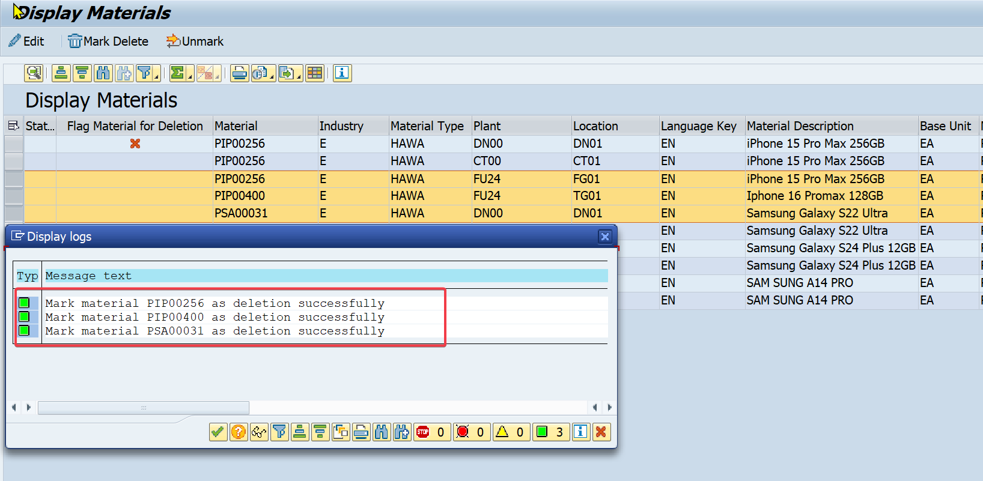

Click 

The result is status *displays green* square  and marked with  in the *Flag for Delete Material column*

Click on to return *Display screen*

Click on to return to the *SAP Easy Access*screen.

#### 2.3.2.3 Undelete line Material data

Enter T-code "***ZMM01***" into the Transaction box



Click ***Execute (Enter)*** 

In the *Material Master Data Management*screen, select **“*Display”***

In the *Parameters,* enter the following informations:

|  |  |  |  |  |
| --- | --- | --- | --- | --- |
| Field | M/O | Data Value |  | Data Value |
| Material | M | ######## (PIP00256) | to | ######## (PSA00098) |
| Industry Sector | O | Default: E |  |  |
| Material Type | O | Default: HAWA, ZDIE |  |  |
| Plant | O | Default: CT00, DN00, FU24 | to | Default: CT00, DN00, FU24 |
| Storage Location | O | Default:CT01, TG01, DN01 | to | Default:CT01, TG01, DN01 |



Click ***Execute*** 

If you want to *Undelete one Material*, select one line *Material data to Unmark*.

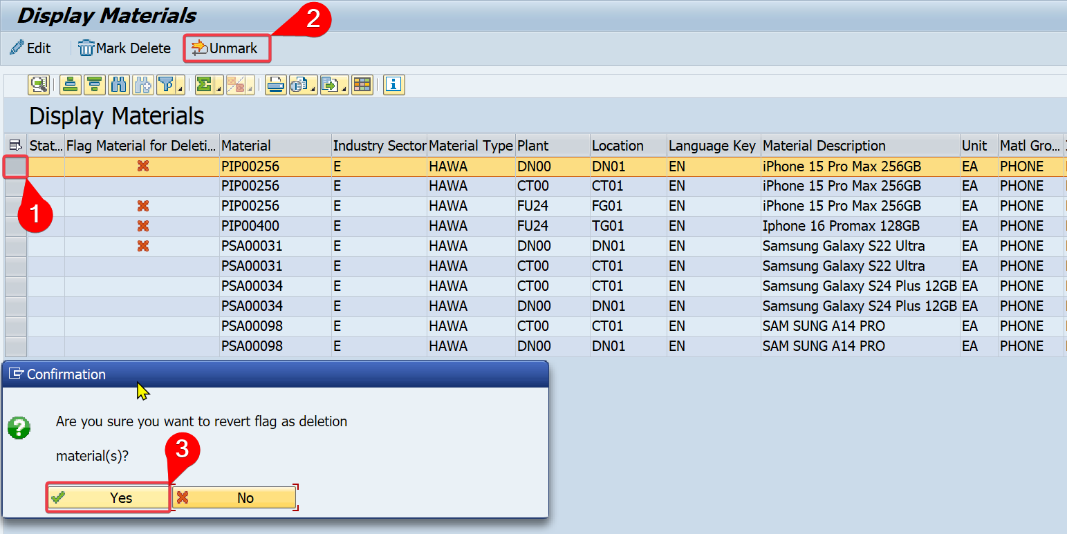

Select line *Material:* ***PIP00256*** *- Plant:* ***DN00****.*

Click 

Click 

You will receive the message that says:



Click . The result is status *displays green square*  and *remove*  in the *Flag for Delete Material column.*

If you want to *Undelete multiple Materials*, you need to select *multiple lines Material data to Unmark*.

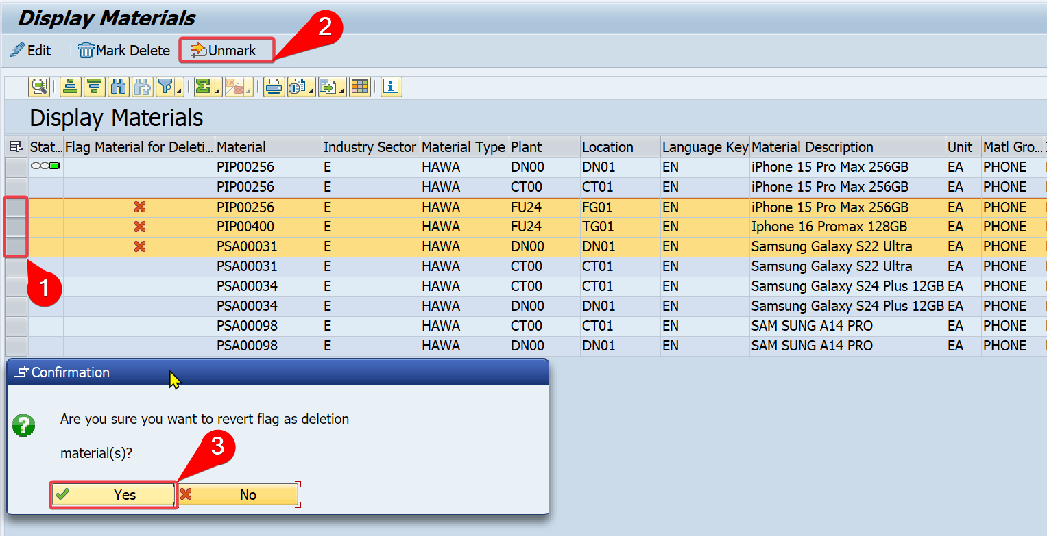

Hold “***Ctrl”*** to select line *Material:* ***PIP000256*** *- Plant* ***FU24***and line *Material:* ***PSA00031*** *- Plant:* ***DN00***

Click 

Click 

You will receive the message that says:

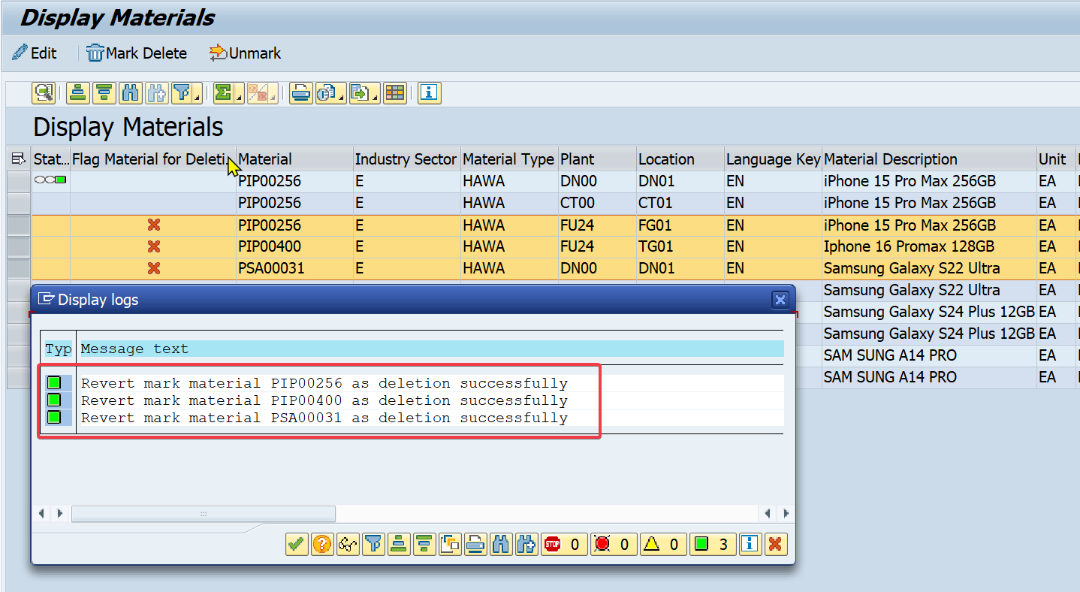

Click . The result is status *displays green square*  and remove  in the *Flag Delete Material column*

Click on to return *Display screen* and can click on to return to the ***SAP Easy Access*** *screen*.

#### 2.3.2.4 No edit data

Enter T-code "***ZMM01***" into the Transaction box



Click ***Execute (Enter)***  or **press Enter**

In the *Material Master Data Management* screen, select **“*Display”***

In the *Parameters,* enter the informations:

|  |  |  |  |  |
| --- | --- | --- | --- | --- |
| **Field** | **M/O** | **Data value** |  | **Data value** |
| Material | M | ######## (PIP00256) | to | ######## (PSA00098) |
| Industry Sector | O | Default: E |  |  |
| Material Type | O | Default: HAWA, ZDIE |  |  |
| Plant | O | Default: CT00, DN00, FU24 | to | Default: CT00, DN00, FU24 |
| Storage Location | O | Default: CT0, TG01, DN01 | to | Default: CT0, TG01, DN01 |



Click ***Execute***  to show ***Display Materials*** screen

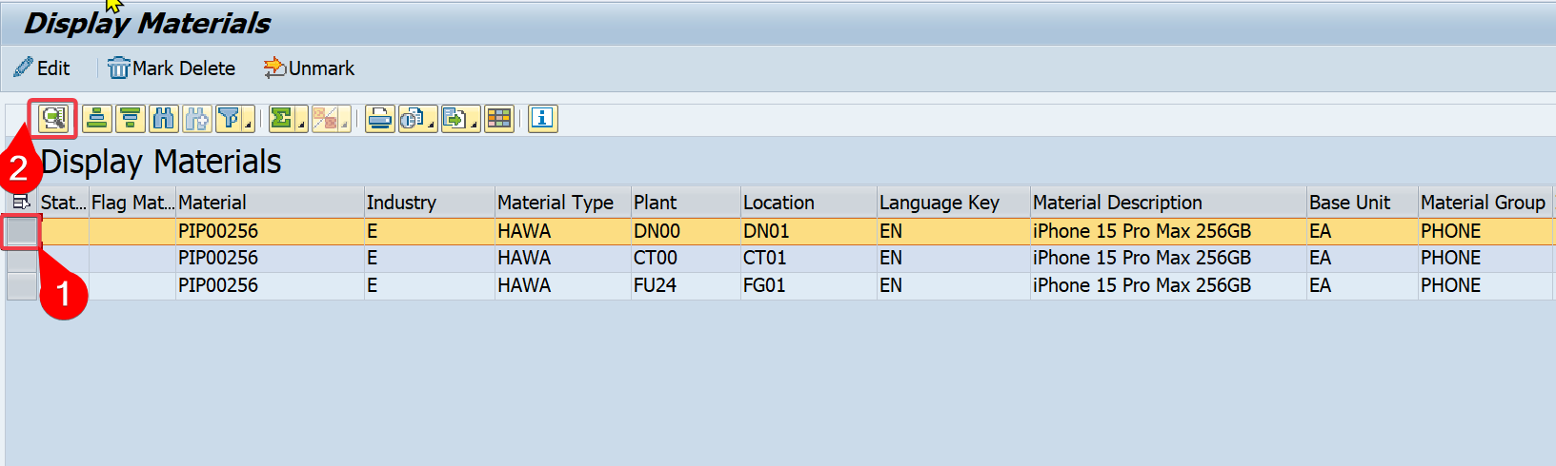

Select line *Material:* ***PIP00256*** *- Plant:* ***CT00****.*

Click  to show data details.

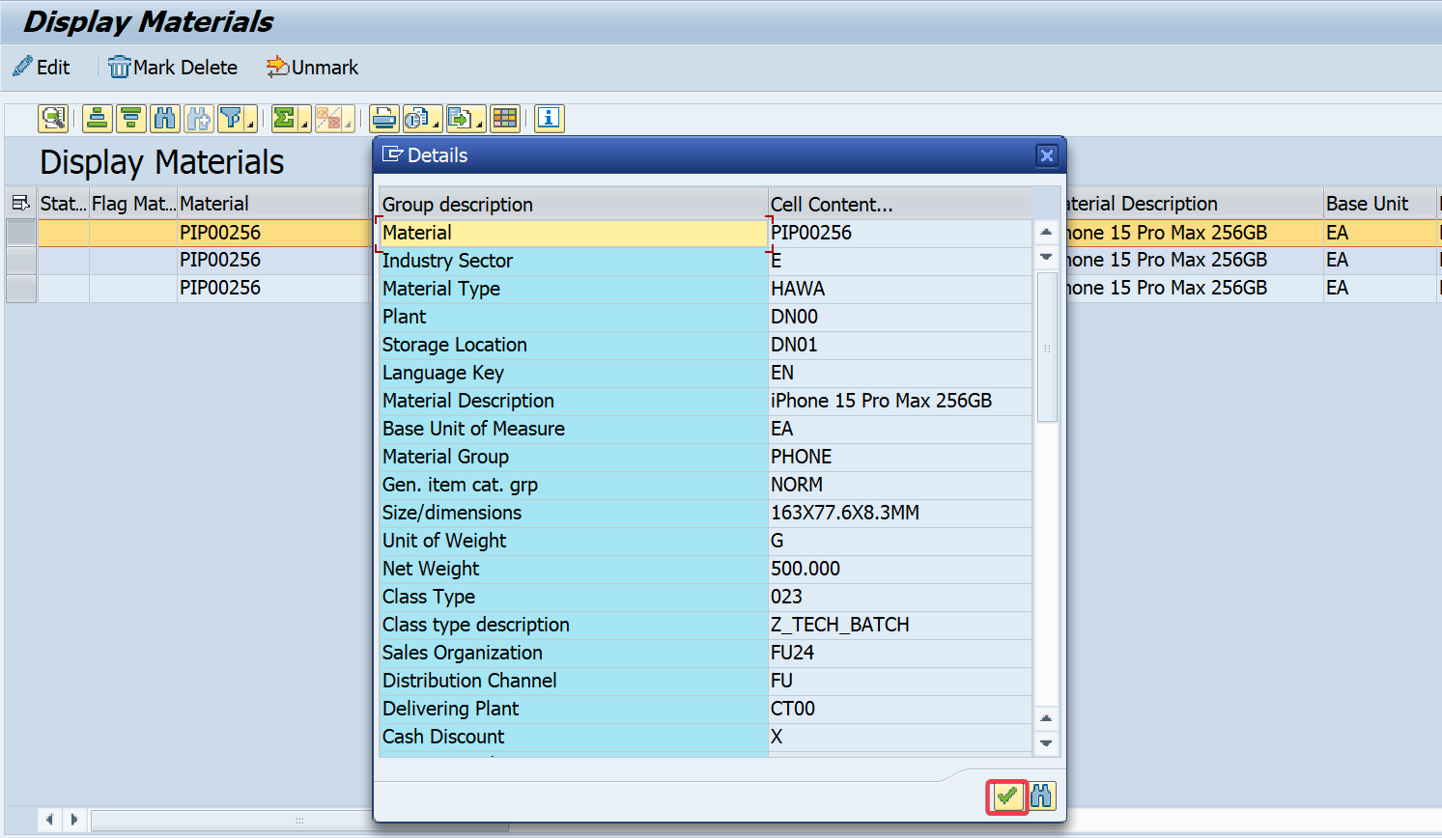

Click 

Click on to return *Display screen*

Click on to return to the *SAP Easy Access screen.*

#### 2.3.2.5 Edit 1 line Material with 1 field

Enter T-code "**ZMM01**" into the Transaction box



Click ***Execute (Enter)*** 

In the *Material Master Data Management s*creen, select **“*Display”***

In the *Parameters screen,* enter the following information:

|  |  |  |  |  |
| --- | --- | --- | --- | --- |
| **Field** | **M/O** | **Data Value** |  | **Data Value** |
| Material | M | ######## (PIP00256) | to | ######## (PSA00098) |
| Industry Sector | O | Default: E |  |  |
| Material Type | O | Default: HAWA, ZDIE |  |  |
| Plant | O | Default: CT00, FU24, DN00 | to | Default: CT00, FU24, DN00 |
| Storage Location | O | Default: CT01, TG01, DN01 | to | Default: CT01, TG01, DN01 |



Click ***Execute*** 

Select line *Material:* ***PSA00031*** *- Plant:* ***CT00***

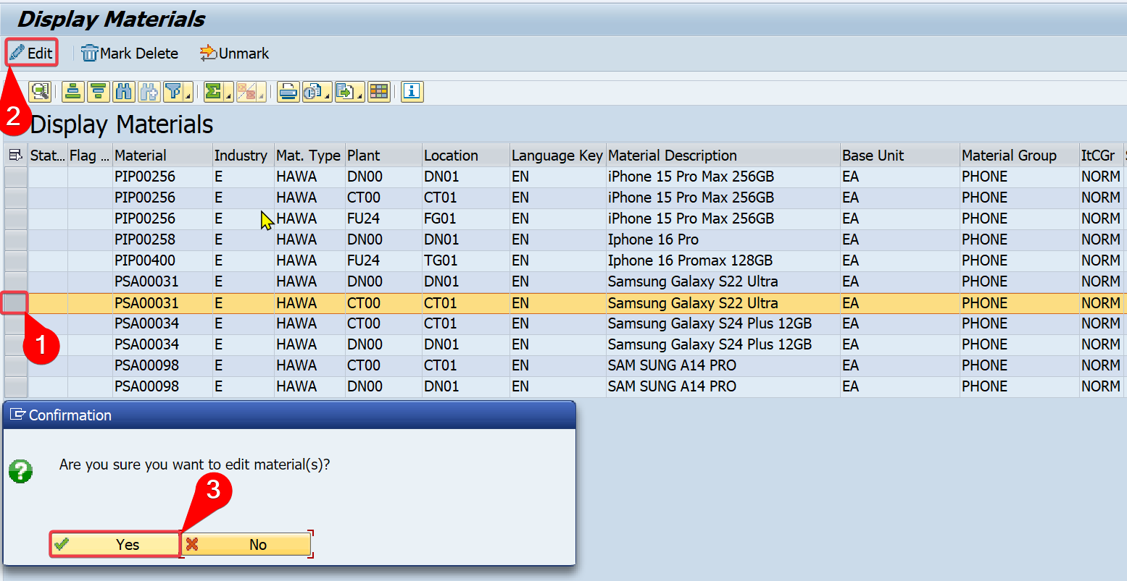

Click 

Click 

Edit field ***Time Unit***

|  |  |
| --- | --- |
| **Field** | **Description** |
| Storage Conditions | 01 |

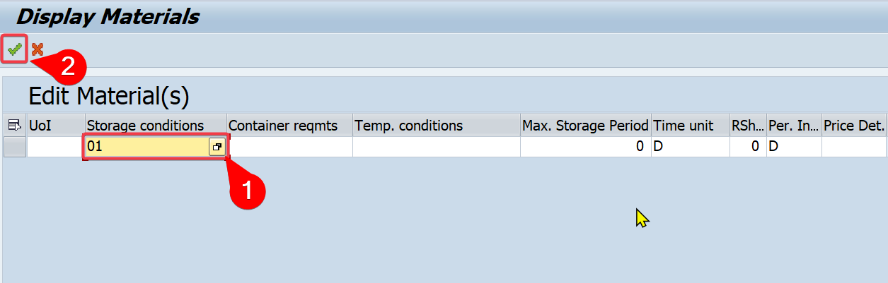

Click 

The result displays Message text and status shows 

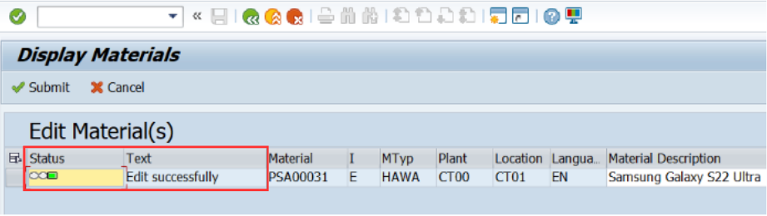

Click  to go back to the *Display Materials screen.*

Click on to return *Display screen*

Click on to return to the *SAP Easy Access screen.*

#### 2.3.2.6 Edit 1 line Material with multiple fields

Enter T-code "***ZMM01***" into the Transaction box



Click ***Execute (Enter)*** 

In the *Material Master Data Management screen*, select **“*Display”***

In the *Parameters screen,* enter the following information:

|  |  |  |  |  |
| --- | --- | --- | --- | --- |
| **Field** | **M/O** | **Data Value** |  | **Data Value** |
| Material | M | ######## (PHU00019) | to | ######## (TSA00115) |
| Industry Sector | O | Default: E |  |  |
| Material Type | O | Default: HAWA, ZDIE |  |  |
| Plant | O | Default: CT00, DN00, FU24 | to | Default: CT00, DN00, FU24 |
| Storage Location | O | Default: CT01, TG01, DN01 | to | Default: CT01, TG01, DN01 |



Click ***Execute*** 

Select line *Material:* ***PHU00019*** *- Plant:* ***FU24***.

Click 

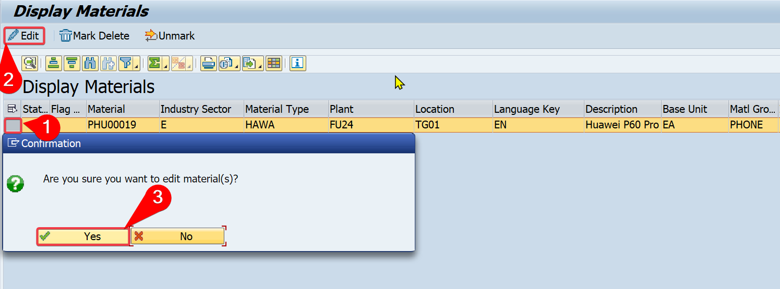

Click 

Edit the information of multiple fields

|  |  |
| --- | --- |
| **Field** | **Description** |
| Cash discount | X |
| Min.order qty | 3 |
| Min.Dely qty | 1 |
| Delivery Unit | 3 |

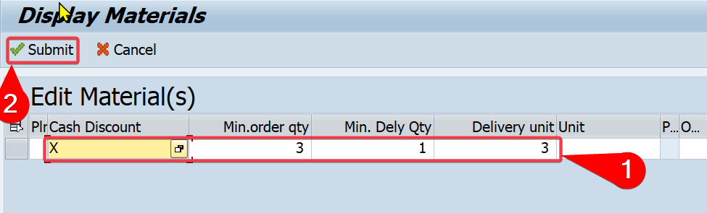

Press ***Enter***

Click 

The result displays Message text *"****Edit successfully*"** and status shows 

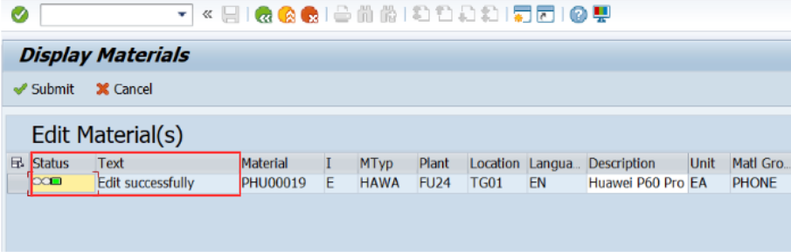

Click  to go back to the *Display Materials screen.*

Click on to return *Display screen*

Click on to return to the *SAP Easy Access* screen.

#### 2.3.2.7 Edit multiple lines Material with multiple fields

Enter T-code "***ZMM01***" into the Transaction box



Click ***Execute (Enter)***  or **press Enter**

In the *Material Master Data Management* screen, select **“*Display”***

In the *Parameters screen,* enter the following information:

|  |  |  |  |  |
| --- | --- | --- | --- | --- |
| **Field** | **M/O** | **Data Value** |  | **Data Value** |
| Material | M | ######## (PHU00019) | to | ######## (TSA00115) |
| Industry Sector | O | Default: E |  |  |
| Material Type | O | Default: HAWA |  |  |
| Plant | O | CT00 | to | FU24 |
| Storage Location | O | CT01 | to | FU24 |



Click ***Execute*** 

Select line *Material:* ***PHU00019*** *- Plant:* ***CT00***, *Material:* ***PIP00256*** *- Plant:* ***CT00*** and *Material:* ***PIP00256*** *- Plant:* ***DN00***

Click 

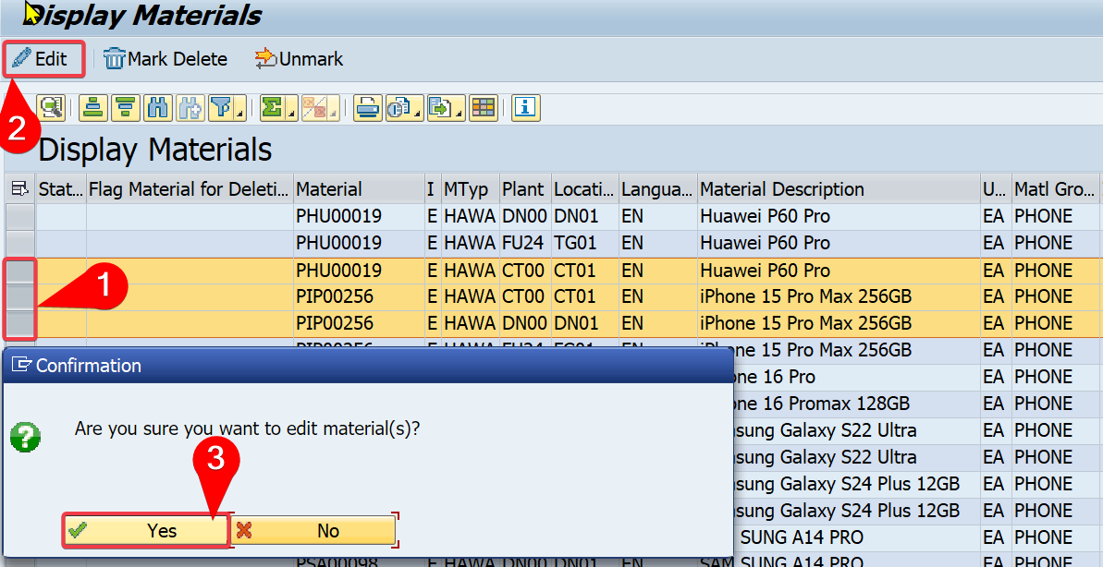

Click 

Edit the following information of multiple fields with multiple lines:

**Material: PHU00019 - Plant: CT00**

|  |  |
| --- | --- |
| **Field name** | **Description** |
| Max. Storage Period | 2 |
| Period Indicator | W |

* **Material: PIP00256 - Plant: CT00**

|  |  |
| --- | --- |
| **Field name** | **Description** |
| Max. Storage Period | 5 |
| Time Unit | D |

* **Material: PIP00258 - Plant: DN00**

|  |  |
| --- | --- |
| **Field name** | **Description** |
| Rem.shelf life | 3 |
| Attribute 2 | 2796 x 1290 Pixels |

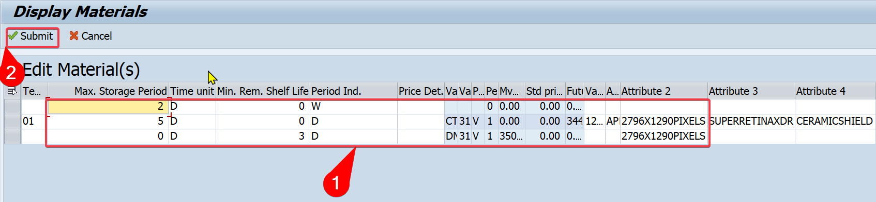

Click 

The result displays Message text **"*Edit successfully*"** and status shows 

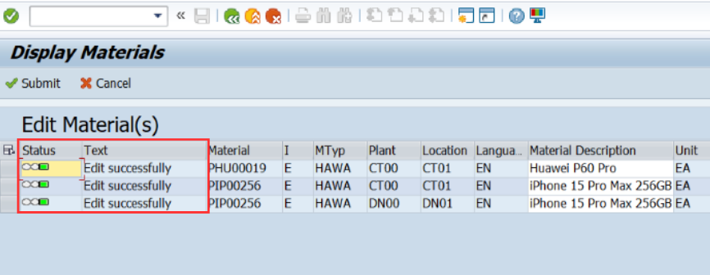

Click  to go back to the *Display Materials*screen.

Click on to return *Display screen*

Click on to return to the *SAP Easy Access* screen.